



**To Supply Leftover Food to Poor**

# Project Overview

# This project is focused on **supplying leftover food to the poor**, designed to address **food wastage and hunger in underserved communities**. The goal is to deliver a comprehensive solution by leveraging **partnerships with restaurants, food suppliers, and community organizations**. Through this project, we aim to enhance **social responsibility, reduce food waste, and improve food security for low-income individuals and families**, supporting the long-term goals of **building a more sustainable and compassionate community**.

# Objectives

* **Business Goals:**
* **Reduce food waste** by creating a sustainable system for redistributing leftover food from restaurants, hotels, and other food establishments to those in need.
* **Enhance community engagement** by involving local businesses and volunteers in the food donation process.
* **Improve public awareness** of food insecurity issues and the environmental impact of food waste.
* **Ensure operational sustainability** through securing long-term partnerships with food donors, community organizations, and funding sources.
* **Specific Outcomes:**
* **Collect and redistribute** a minimum of **X tons of leftover food per month** to underserved populations.
* **Establish partnerships** with at least **10 local businesses and food suppliers** within the first 6 months.
* **Create a volunteer network** of at least **50 active members** to support food collection, packaging, and distribution.
* **Develop a digital platform** or app to track food donations, logistics, and delivery, with **X% accuracy** in matching food supply with demand.
* **Raise awareness** through at least **5 community events** and social media campaigns, increasing engagement by **X%** within the first year.

**3. Salesforce Key Features and Concepts Utilized**

. Key Salesforce features and concepts that help streamline and scale the initiative include:

1. **Custom Objects for Food Donations and Distribution:**
   * Custom objects are created to track key elements such as **Food Donations**, **Donors**, **Recipients (beneficiaries)**, and **Volunteers**. This allows easy management of the food supply chain, from donation to distribution, ensuring transparency and accountability in the process.
2. **Salesforce Communities (Experience Cloud):**
   * A **Salesforce Community** (or portal) is set up for **food donors**, **volunteers**, and **recipients**. The platform enables donors to register, schedule donations, and track their contributions. Volunteers can sign up, check their shifts, and communicate with the project team, while recipients can access food distribution schedules and request assistance.
3. **Automation with Salesforce Flow:**
   * **Salesforce Flow** is used to automate key processes, such as:
     + **Donor registration and food pickup scheduling**.
     + **Volunteer assignment** for food collection and delivery.
     + **Notifications and alerts** for donors, volunteers, and recipients regarding upcoming food pickups and distributions.
4. **Reports & Dashboards for Real-Time Monitoring:**
   * Custom **reports and dashboards** are created to provide real-time visibility into important metrics like:
     + Total **food donations** received and distributed.
     + **Volunteer hours** and participation rates.
     + **Geographical coverage** and number of recipients served. These reports allow project managers to track progress, identify areas for improvement, and make data-driven decisions to enhance the initiative.
5. **Campaign Management for Awareness and Fundraising:**
   * **Salesforce Campaigns** are used to run awareness campaigns, solicit donations, and fundraise for operational costs. This includes creating targeted email campaigns to engage potential donors and raise awareness of the project's impact.
6. **Process Automation with Workflow Rules:**
   * **Workflow Rules** and **Process Builder** are used to automate tasks such as sending reminders to donors, assigning volunteer tasks based on availability, and notifying recipients of upcoming food distributions. This ensures smooth communication and minimizes the risk of human error.
7. **Chatter for Internal Collaboration:**
   * **Salesforce Chatter** enables seamless communication among team members, volunteers, and partners. It allows for quick updates, feedback, and collaboration in real-time, improving coordination between different stakeholders involved in food collection, sorting, and delivery.
8. **Mobile Accessibility:**
   * The **Salesforce mobile app** ensures that volunteers, food donors, and project coordinators can access key information while on-the-go. Volunteers can update their availability, log activities, and view food delivery routes, while donors can track their past contributions and make new donations from anywhere.
9. **Data Security and Compliance:**
   * Salesforce ensures the security and privacy of donor and recipient data through **robust security protocols** and compliance with data protection regulations, ensuring that sensitive information is handled responsibly and securely.
10. **Integration with External Tools (Logistics & Mapping):**
    * Integration with third-party **mapping and logistics tools** helps optimize food distribution routes, ensuring that food is delivered efficiently to those who need it most. Integration with **payment processing systems** can also support fundraising efforts.

# Detailed Steps to Solution Design

# Step 1: Create the Developer Account.

By using this <https://developer.salesorce.com> link ,we have created our salesforce Developer Account by filling the required details(“username”).

**Step 2: Account Activation.**

After completing the Step 1 ,we have received the confirmation **Email .** In that mail we are requested to **Verify and Activate** the salesforce Developer Account. It might take 5-10 minutes to complete the verification process. Then Enter your password and answered your security question.

**Step 3: Create the object in the Salesforce Platform**.

* In setup page, select the **Object Manager ,** click on create and select custom Object.
* Give the label name as venue and save the object venue.
* And same procedure followed for Drop-off point , Volunteer, Task and Execution Details.
* Created object are shown in below screenshots.

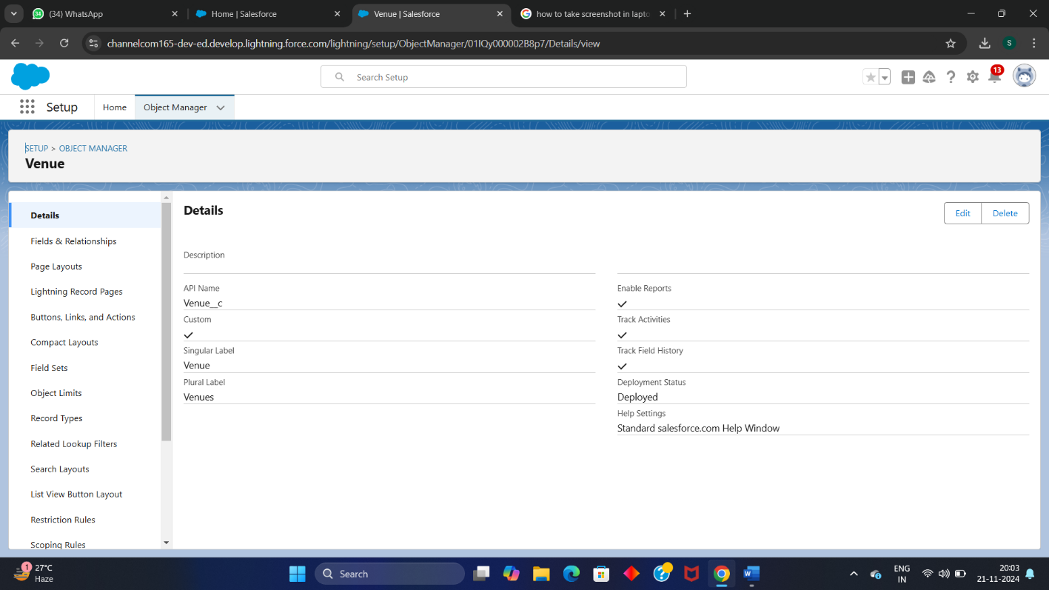

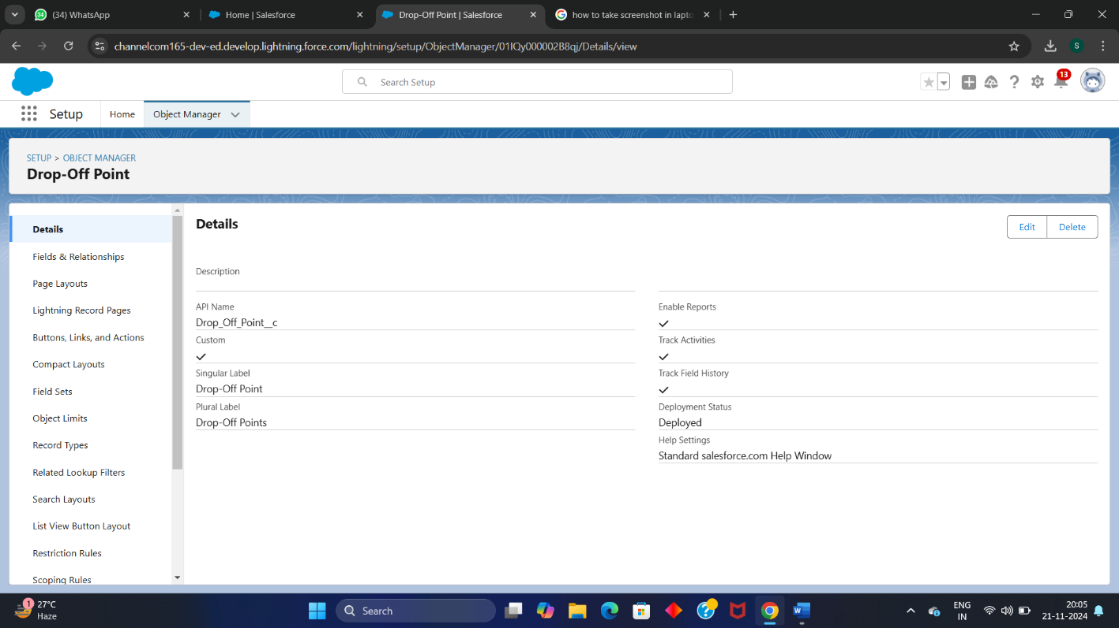

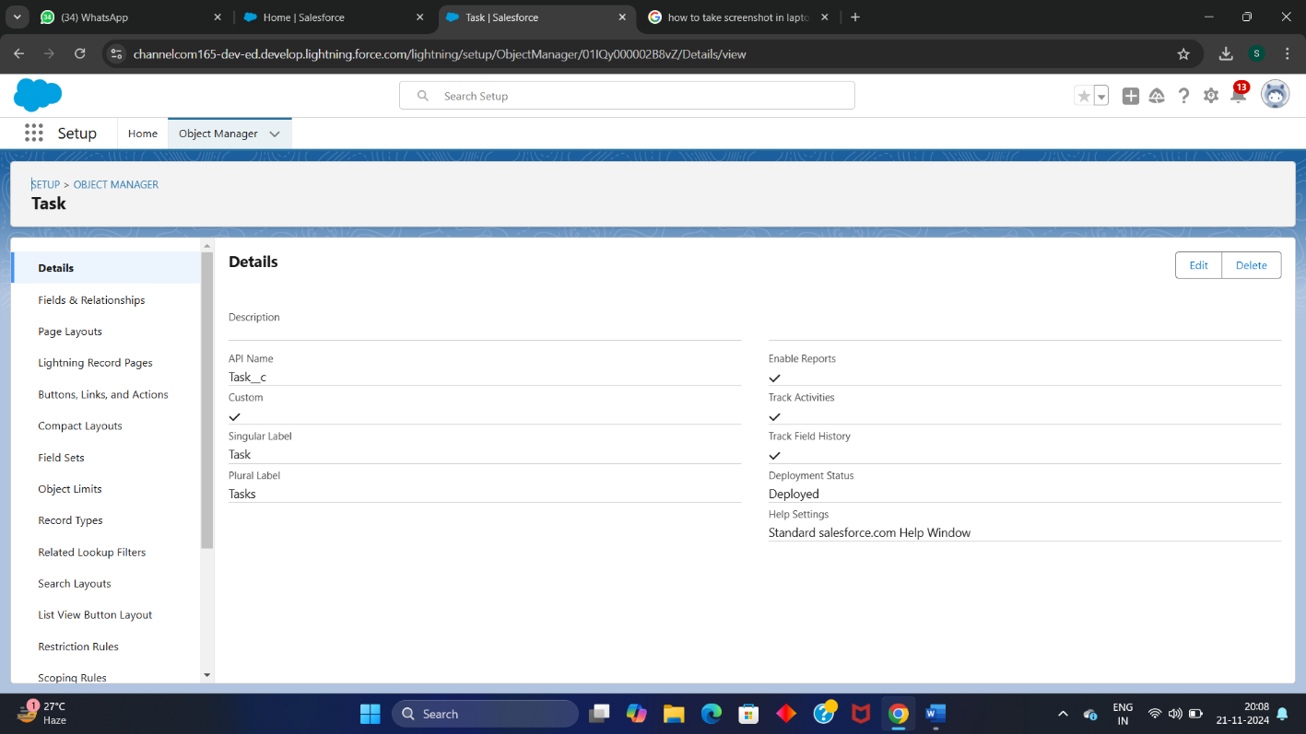

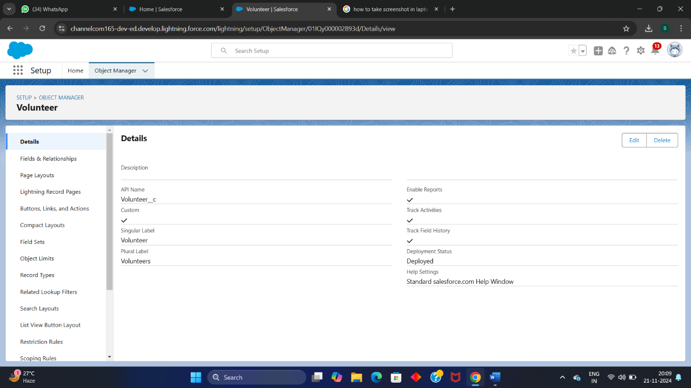

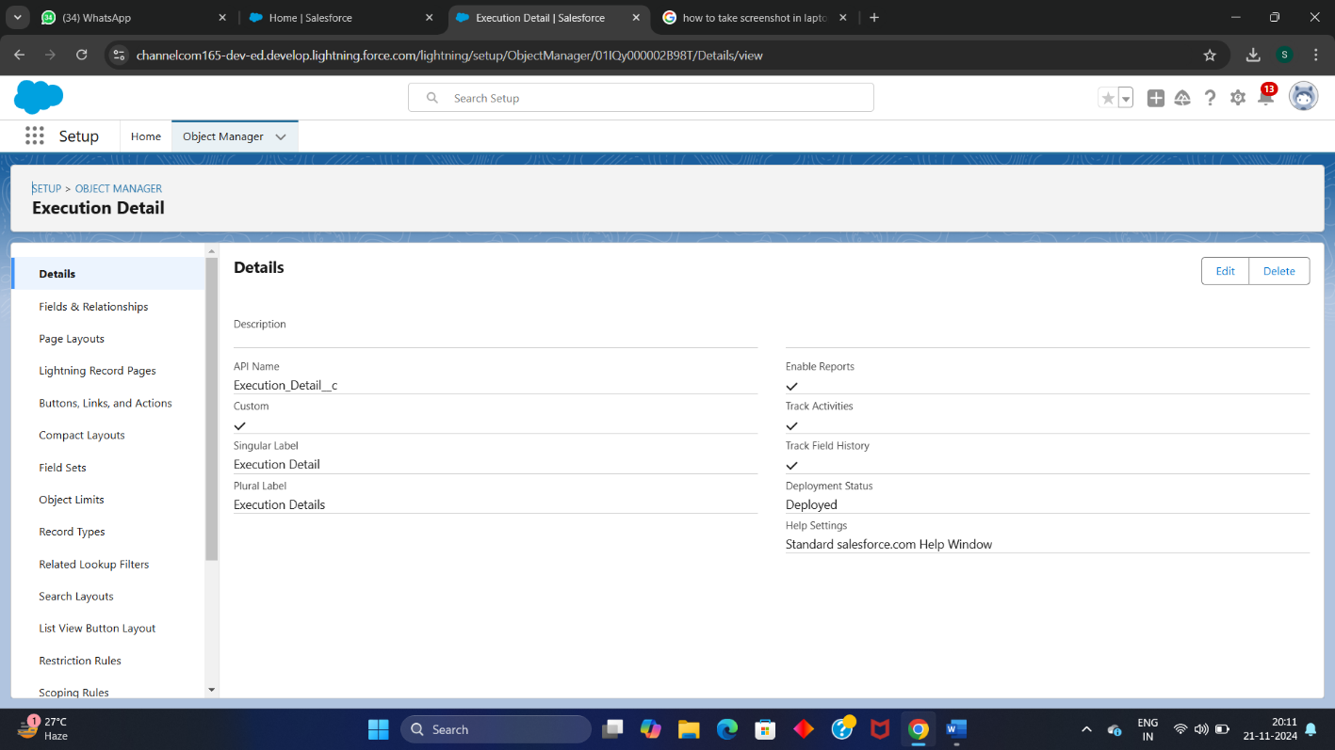

**Step 4: Creating a custom Tab.**

* Navigate to setup page , select **TAB** in the quick find bar.
* Now create for venue by click the new tabs , then select the object Venue and tab style , click on save.
* Repeat the same process for remaining object (“Volunteer ,Drop-off point, Task and Execution Details”)
* Adding the screenshot of Tab next page

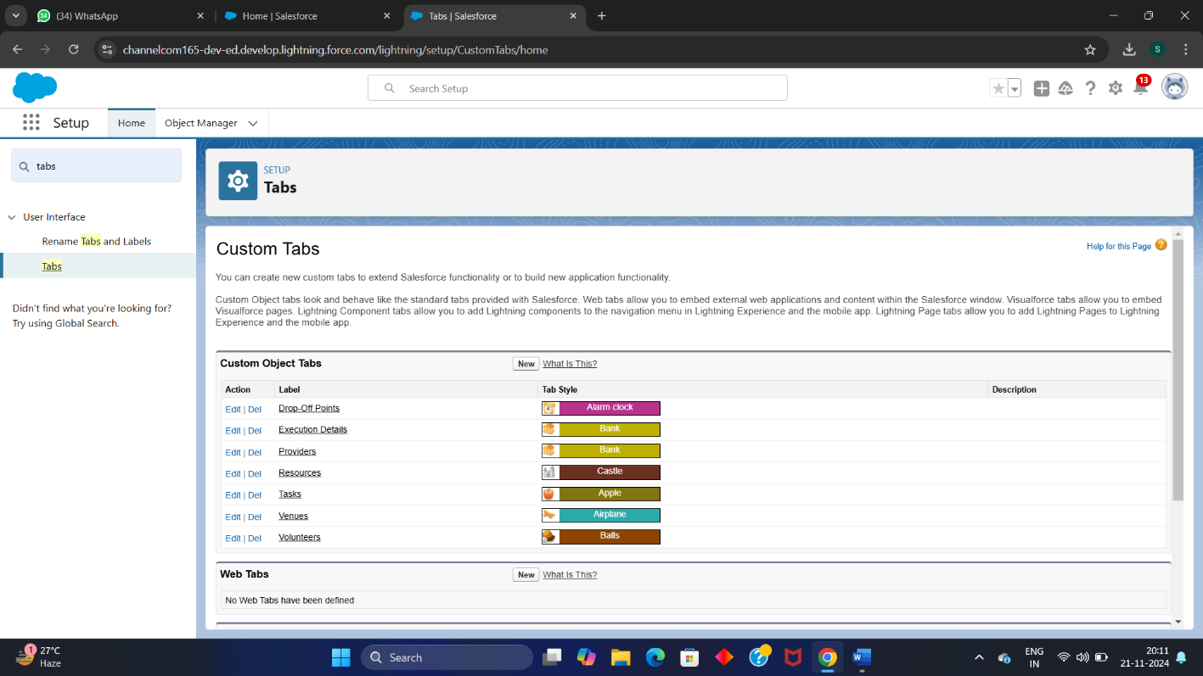

**Step 5: Creating the Lightning App.**

* In setup ,search App Manager in quick find Bar, then click on new lightning app.
* Give the app name as **Food-Connect** andupload your profile photo .
* In next page , Available item are shown .
* Add the necessary item like Home, Venue, Drop-off point, Task, Execution Detail ,Volunteer ,Report and Dashboard to the selected item.
* Then add USER PROFILE as System Administrator and save your lightning app.

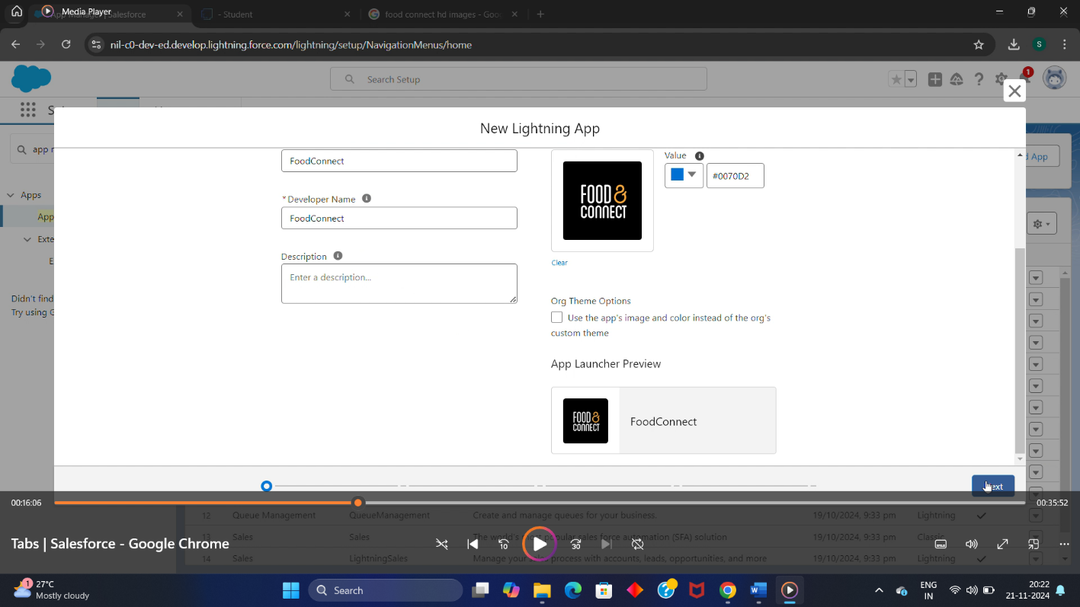

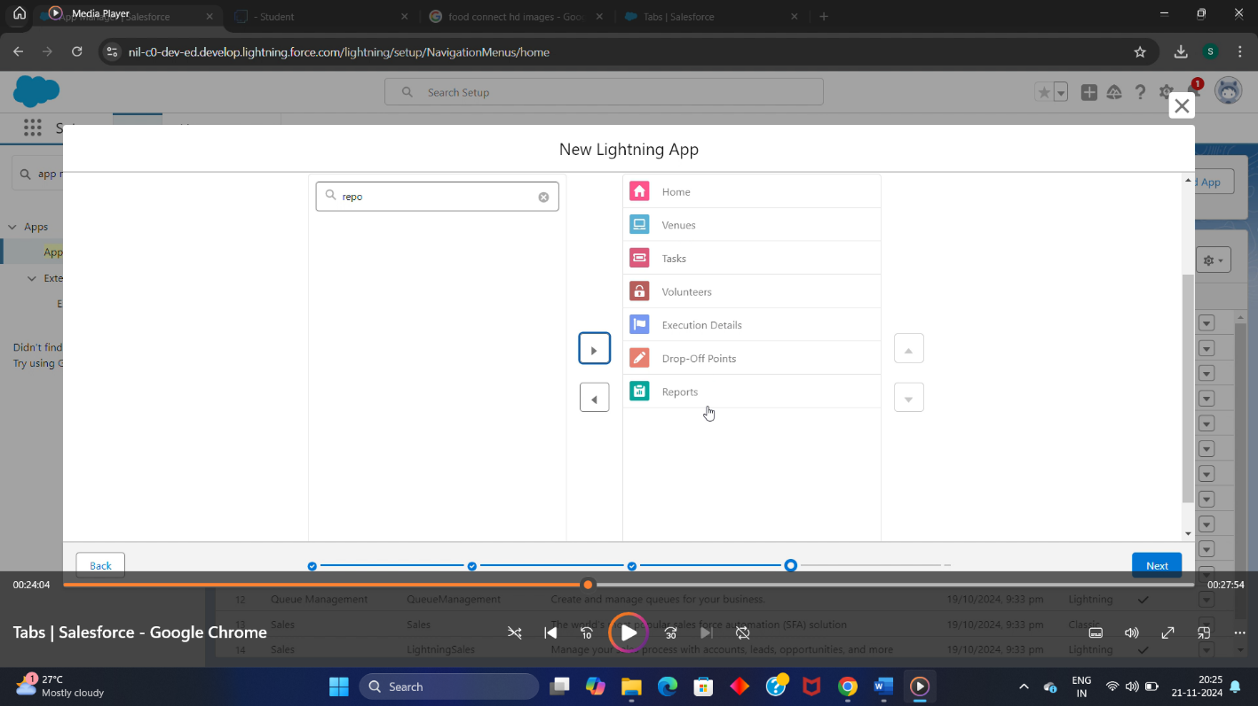

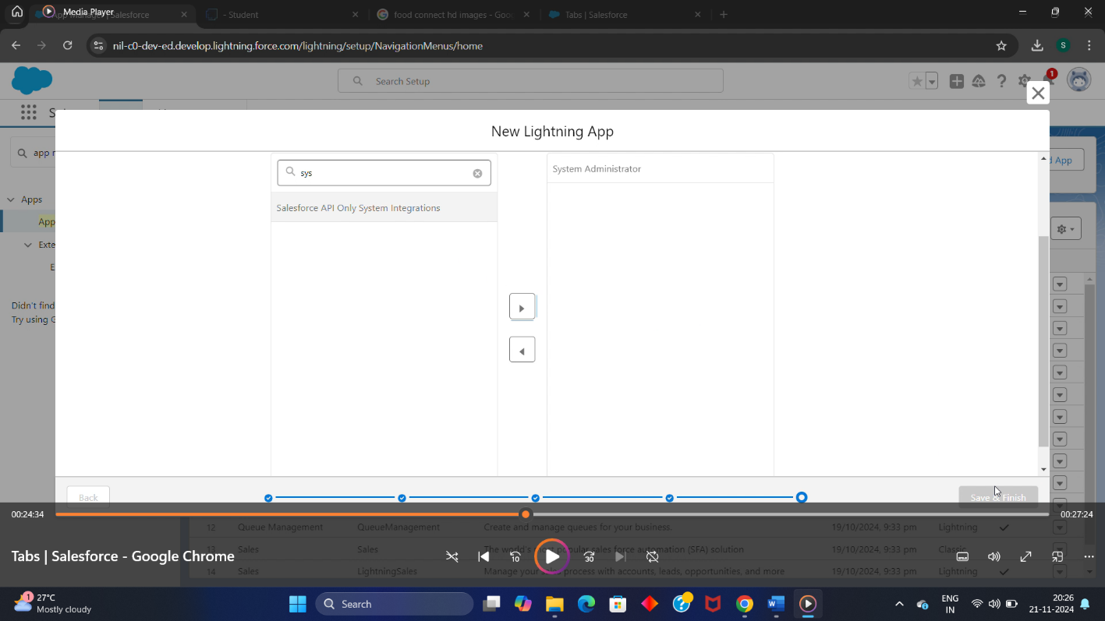

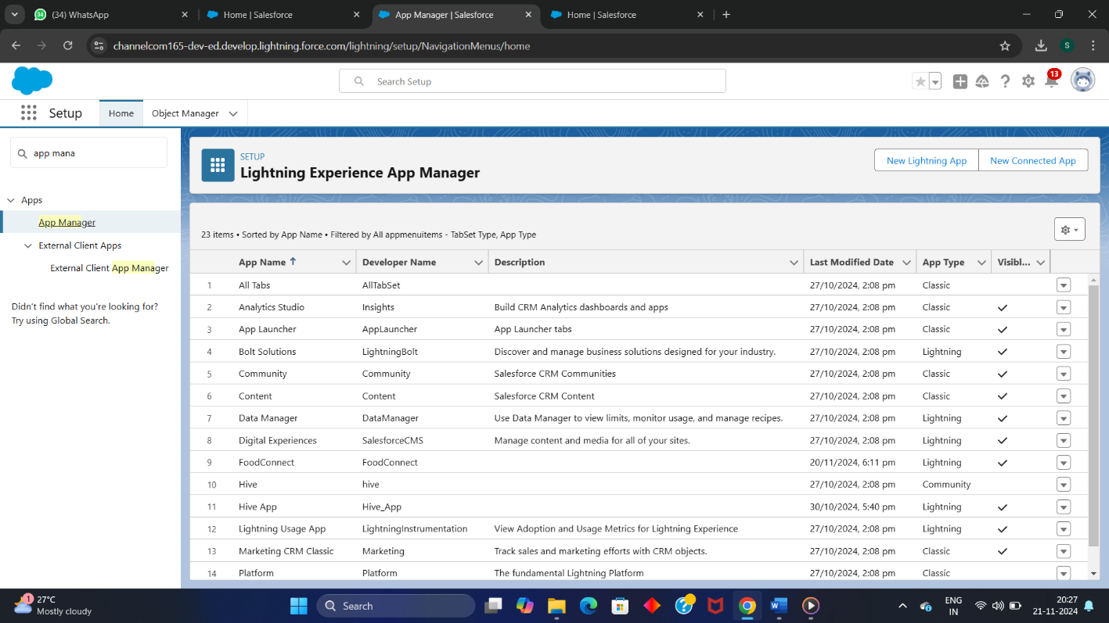

**Step 6 : Creating the Fields for Object.**

* **Creation of relationship field on volunteer object.**
* In volunteer object , select fields and relationship .
* Then create Master-detail relationship between Drop-off point object and volunteer .
* Click on save .
* **Creation of relationship field on Execution detail.**
* In Execution Detail object , select fields and relationship .
* Then create Master-detail relationship between Execution detail and volunteer
* Click on save .
* **Creation of relationship field on Execution detail.**
* In Execution Detail object , select fields and relationship .
* Then create Master-detail relationship between Execution detail and Task.
* Click on save .
* **Creation of relationship field on Drop-off point.**
* In Task object , select fields and relationship .
* Then create Lookup relationship between Task and Drop-off point
* Click on save .
* **Creation of relationship field on Task.**
* In Task object , select fields and relationship .
* Then create Lookup relationship between Venue and Task.
* Click on save .
* **Creation of relationship field on Task.**
* In Task object , select fields and relationship .
* Then create Lookup relationship between Drop-off point and Task.
* Click on save .
* **Creation of relationship field on Venue .**
* In Venue object , select fields and relationship .
* Then select datatypes as Email .
* Click on save .
* **Creation of relationship field on Venue.**
* In Venue object , select fields and relationship .
* Then select datatypes as Phone .
* Click on save .
* **Creation of relationship field on Venue .**
* In Venue object , select fields and relationship .
* Then select datatypes as Geolocation .
* Give field label as Location .
* Click on save .
* **Creation of relationship field on Venue .**
* In Venue object , select fields and relationship .
* Then select datatypes as Text Area(long) .
* Give field label as Venue Location .
* Click on save .
* **Creation of relationship field on Drop-off point .**
* In Drop-off point object , select fields and relationship .
* Then select datatypes as Geolocation .
* Give field label as Location 2 .
* Click on save .
* **Creation of relationship field on Drop-off point .**
* In Drop-off point object , select fields and relationship .
* Then select datatypes as Formula.
* Give field label as distance calculation.
* Click on save

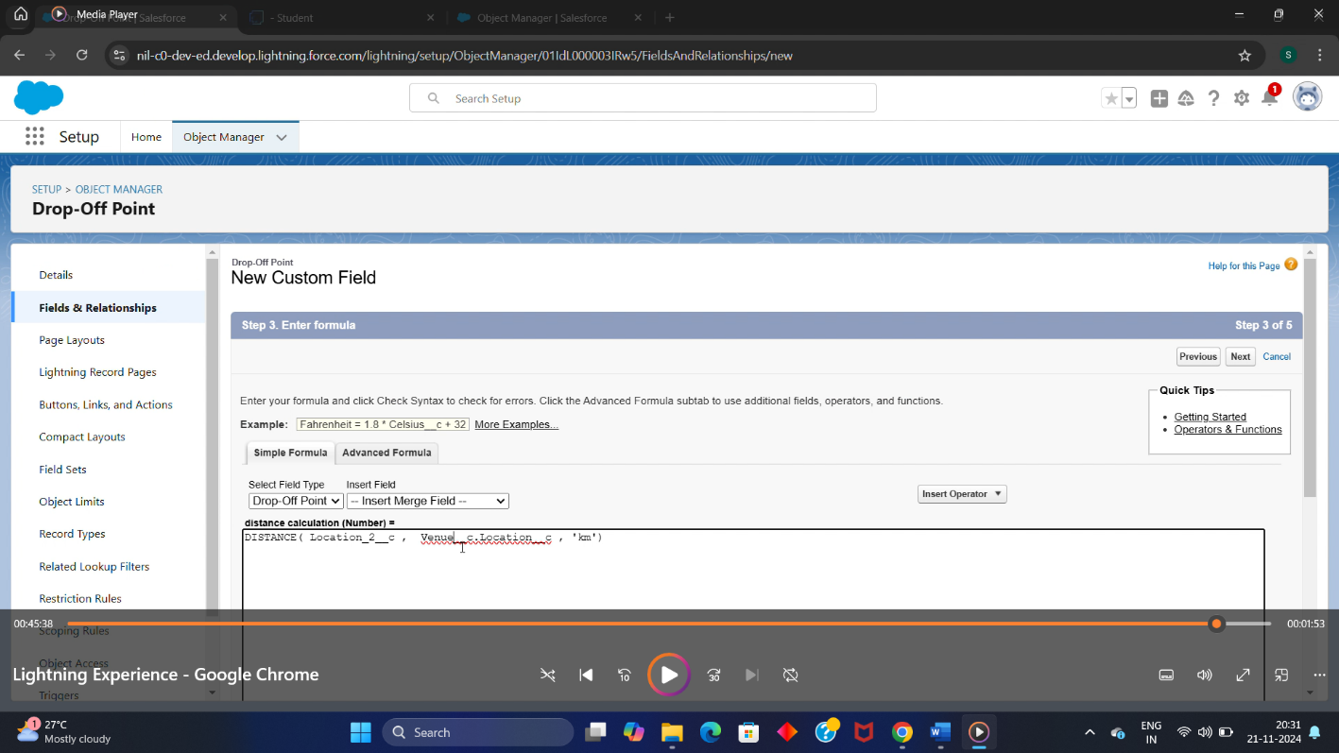

* **Creation of relationship field on Drop-off point .**
* In Drop-off point object , select fields and relationship .
* Then select datatypes as Picklist.
* Give field label as state and particular values for it.
* Click on save
* **Creation of relationship field on Task.**
* In Task object , select fields and relationship .
* Then select datatypes as Number.
* Give field label as Distance.
* Click on save.
* **Creation of relationship field on Task.**
* In Task object , select fields and relationship .
* Then select datatypes as auto-Number.
* Give field label as Task ID.
* Click on save
* **Creation of relationship field on Task.**
* In Task object , select fields and relationship .
* Then select datatypes as Date.
* Give field label as Date.
* Click on save
* **Creation of relationship field on Task.**
* In Task object , select fields and relationship .
* Then select datatypes as picklist.
* Give field label as Food Category and particular varieties
* Click on save
* **Creation of relationship field on Task.**
* In Task object , select fields and relationship .
* Then select datatypes as Number.
* Give field label as No of people served.
* Click on save
* **Creation of relationship field on Task.**
* In Task object , select fields and relationship .
* Then select datatypes as Text.
* Give field label as Name of the person.
* Click on save
* **Creation of relationship field on Task.**
* In Task object , select fields and relationship .
* Then select datatypes as Phone.
* Give field label as phone.
* Click on save
* **Creation of relationship field on Task.**
* In Task object , select fields and relationship .
* Then select datatypes as picklist.
* Give field label as Rating.
* Click on save
* **Creation of relationship field on Task.**
* In Task object , select fields and relationship .
* Then select datatypes as long text area.
* Give field label as Feedback.
* Click on save.
* **Creation of relationship field on Volunteer.**
* In Volunteer object , select fields and relationship .
* Then select datatypes as Auto-Number.
* Give field label as Volunteer ID.
* Click on save
* **Creation of relationship field on Volunteer.**
* In Volunteer object , select fields and relationship .
* Then select datatypes as picklist.
* Give field label as Gender.
* Click on save
* **Creation of relationship field on Volunteer.**
* In Volunteer object , select fields and relationship .
* Then select datatypes as date.
* Give field label as Available on.
* Click on save
* **Creation of relationship field on Volunteer.**
* In Volunteer object , select fields and relationship .
* Then select datatypes as Number.
* Give field label as Age.
* Click on save
* **Creation of relationship field on Volunteer.**
* In Volunteer object , select fields and relationship .
* Then select datatypes as Email
* Give field label as Email.
* Click on save
* **Creation of relationship field on Volunteer.**
* In Volunteer object , select fields and relationship .
* Then select datatypes as Number.
* Give field label as Contact Number.
* Click on save
* **Creation of relationship field on Volunteer.**
* In Volunteer object , select fields and relationship .
* Then select datatypes as text Area.
* Give field label as Address.
* Click on save
* **Creation of relationship field on Volunteer.**
* In Volunteer object , select fields and relationship .
* Then select datatypes as date.
* Give field label as Date of Birth.
* Click on save
* **Creation of relationship field on Execution Detail.**
* In Volunteer object , select fields and relationship .
* Then select datatypes as Auto number.
* Give field label as Execution ID.
* Click on save

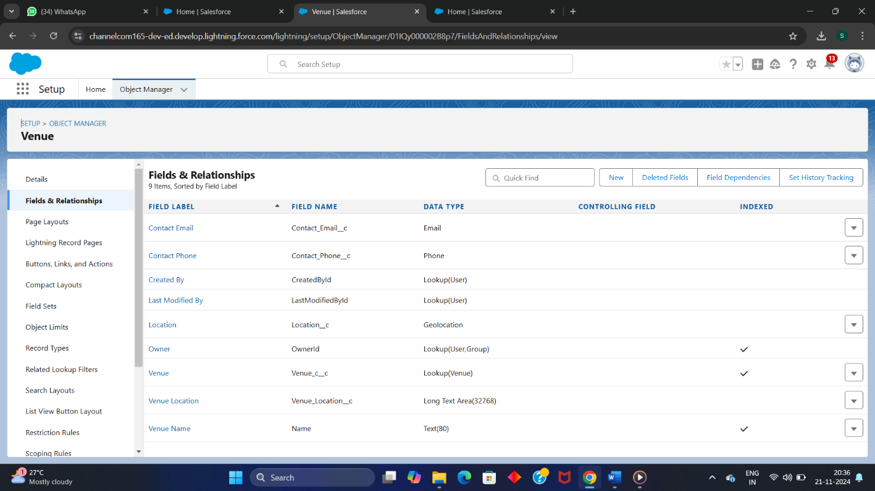

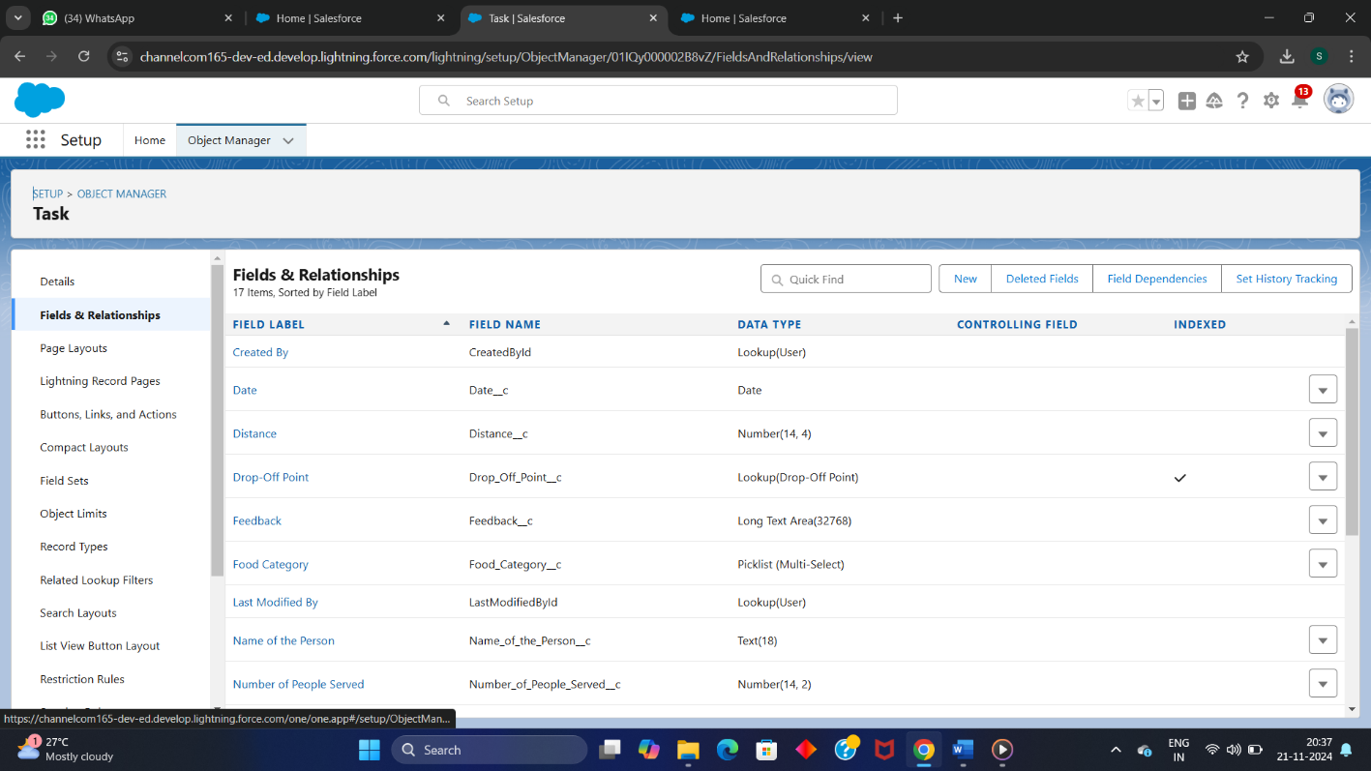

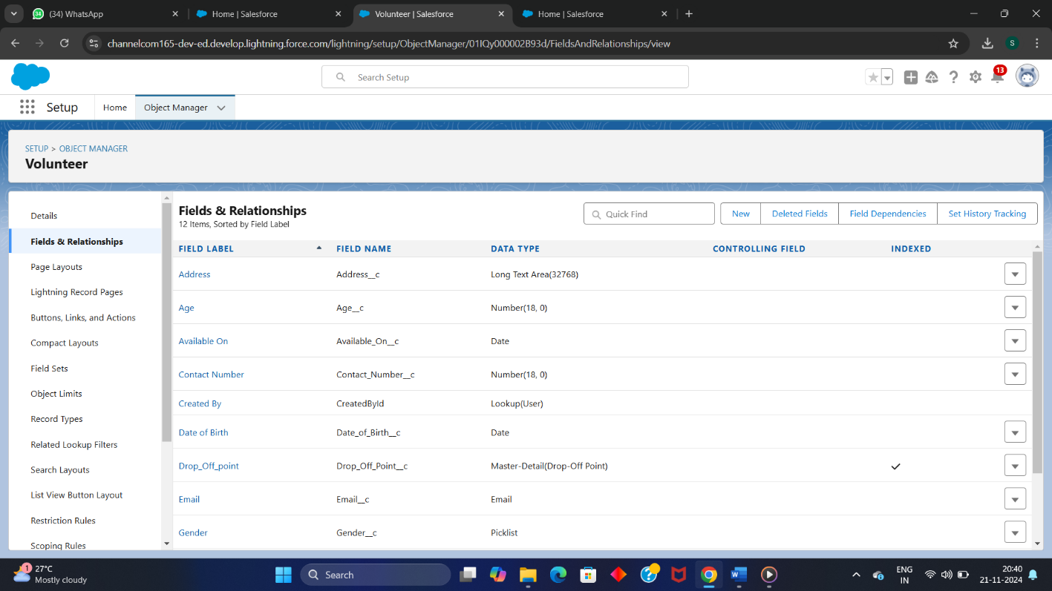

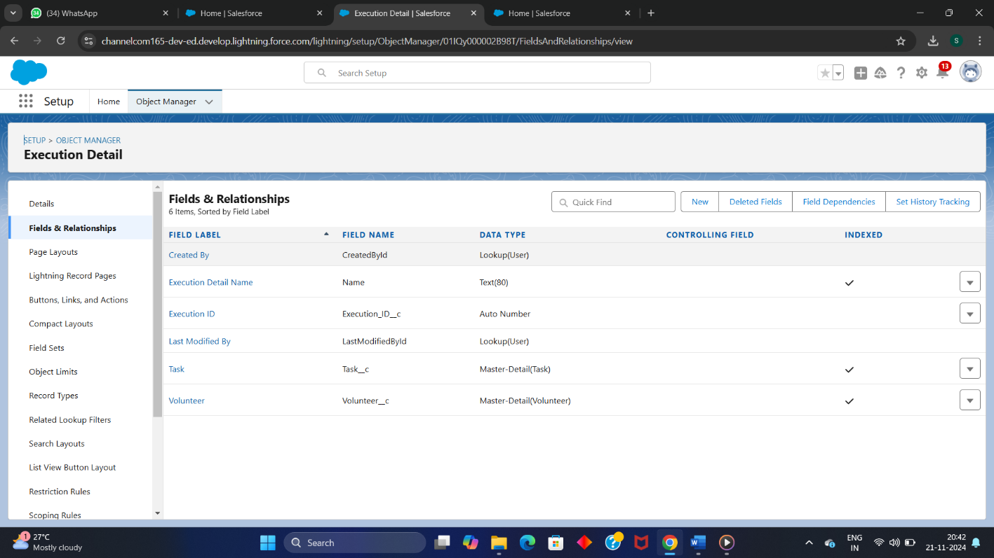

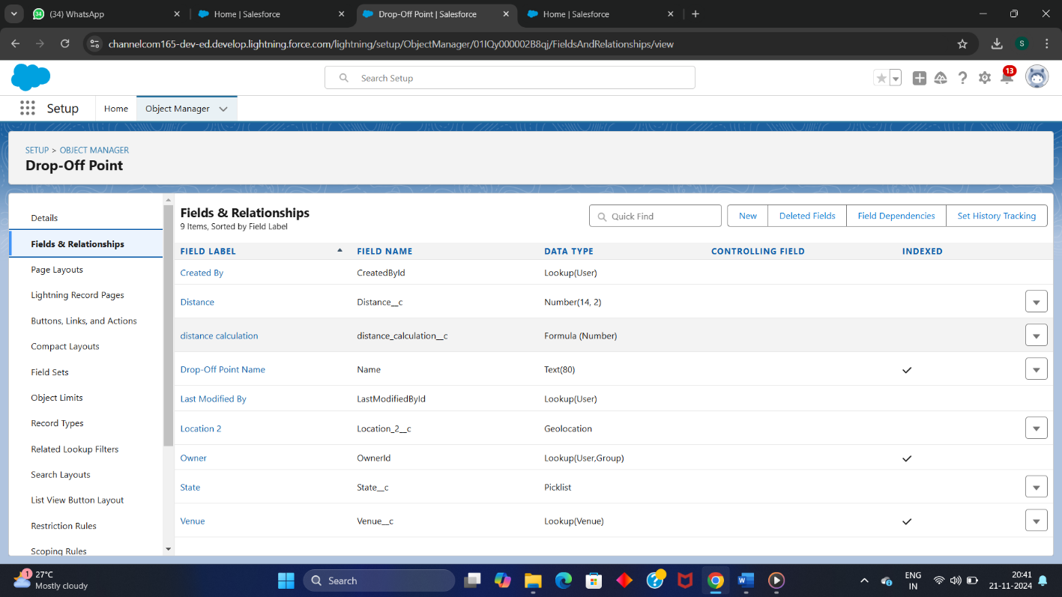

**Step 7: Create flows.**

* Navigate to setup page, search for Flow in quick find bar.
* Click on new flow create the flow Venue form.
* Give screen properties name as “Venue details “.
* Then add components in flow (“text, Email, phone , text , number, number”).
* Then add venue record details and add fields ( Email , phone , venue name, venue location , latitude , longitude).
* Then click on save and activate the flows.
* The screenshot for this process are attached below .

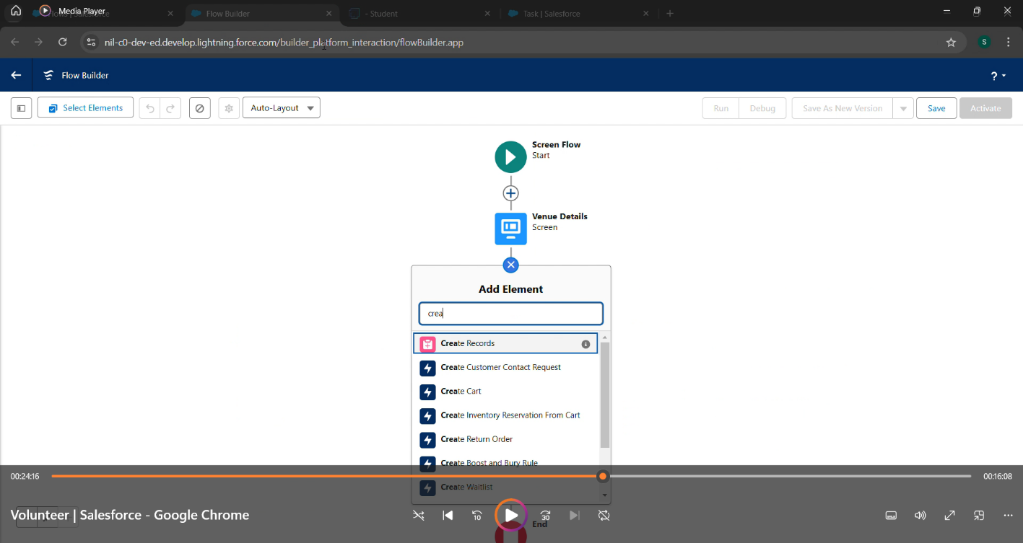

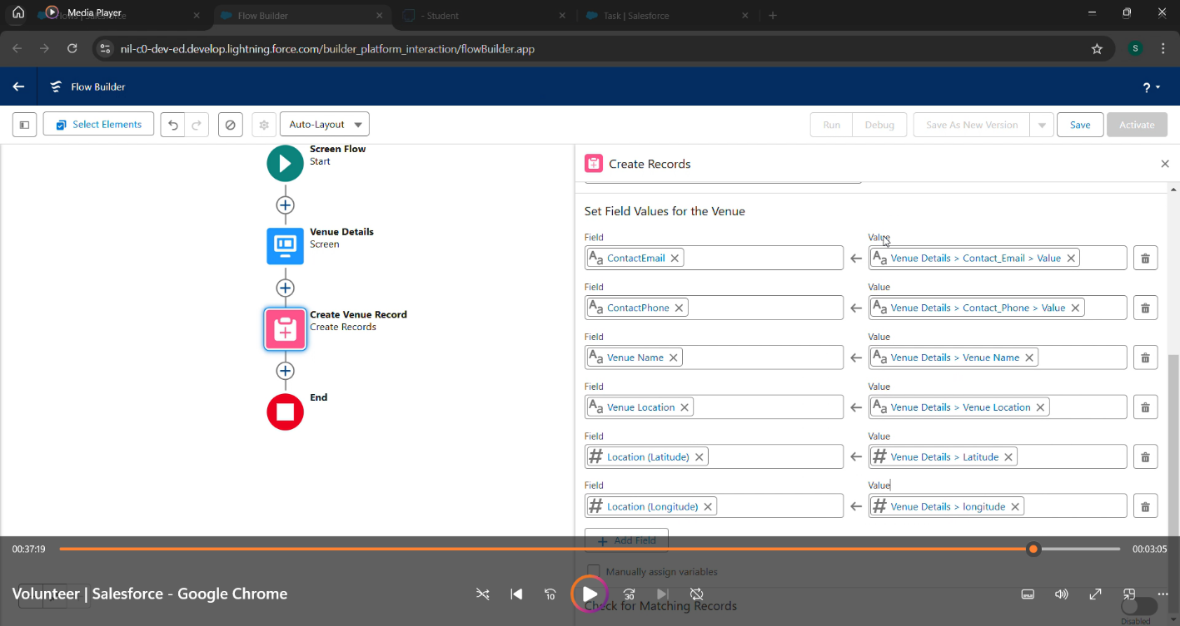

**Step 8: Create an Trigger.**

* Create the new file name in Apex-Trigger .
* Give the name of the trigger as Drop-off trigger. And object as Drop -off point.
* Enter the trigger code for the distance calculation
* Now click on submit
* 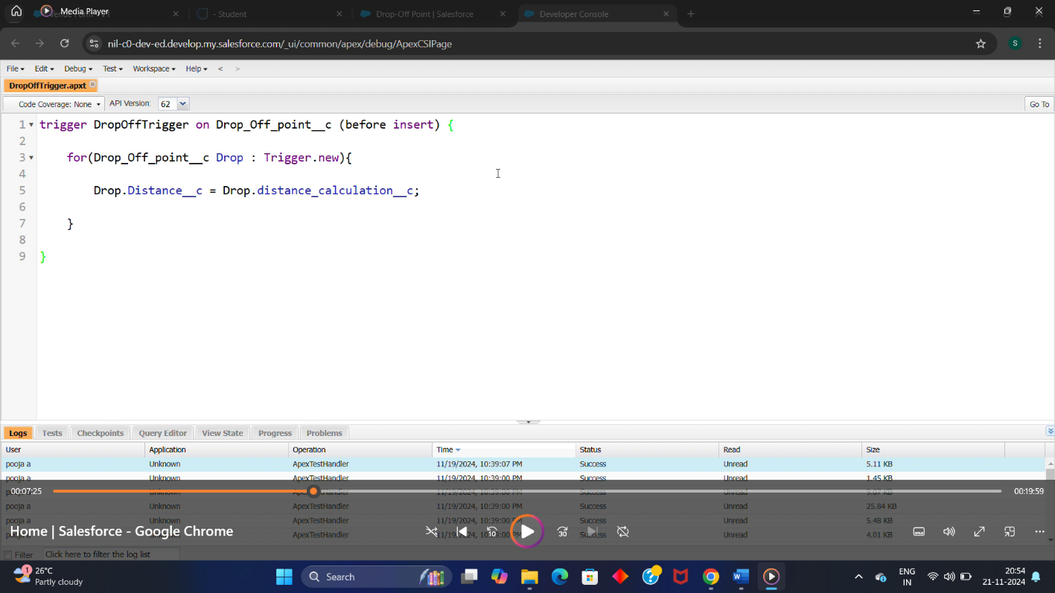

**Step 9: Creation of Profile.**

* In setup page , search for profiles in the quick find bar.
* Click s alphabet and give profile name as NGO’s Profile.
* Then click on save.

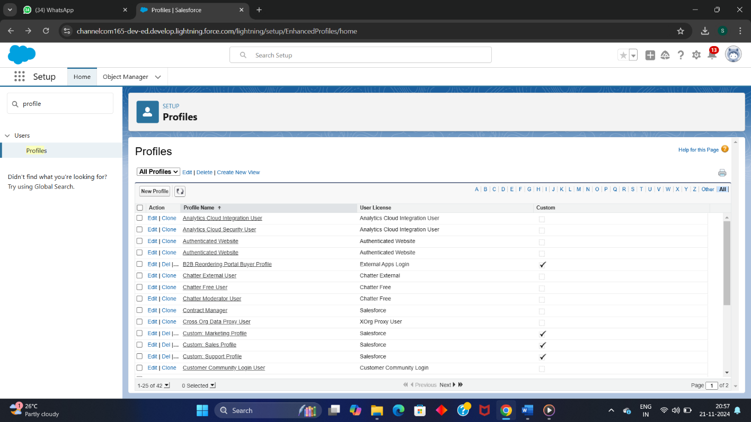

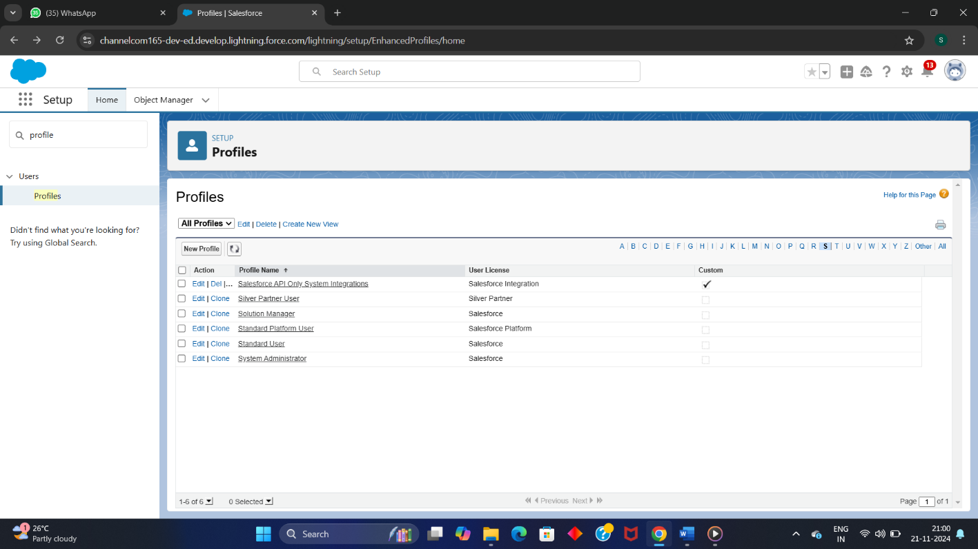

**Step 10: Creation of users.**

* Go to setup page, search for Users and click on new users.
* Give user first name as Iksha Foundation ,email id ,username , nickname.
* Give user license as salesforce platform and profile as NGO’s profile
* Click on save
* By using the same step user Nijami and user Esha has been created as shown in below figure.

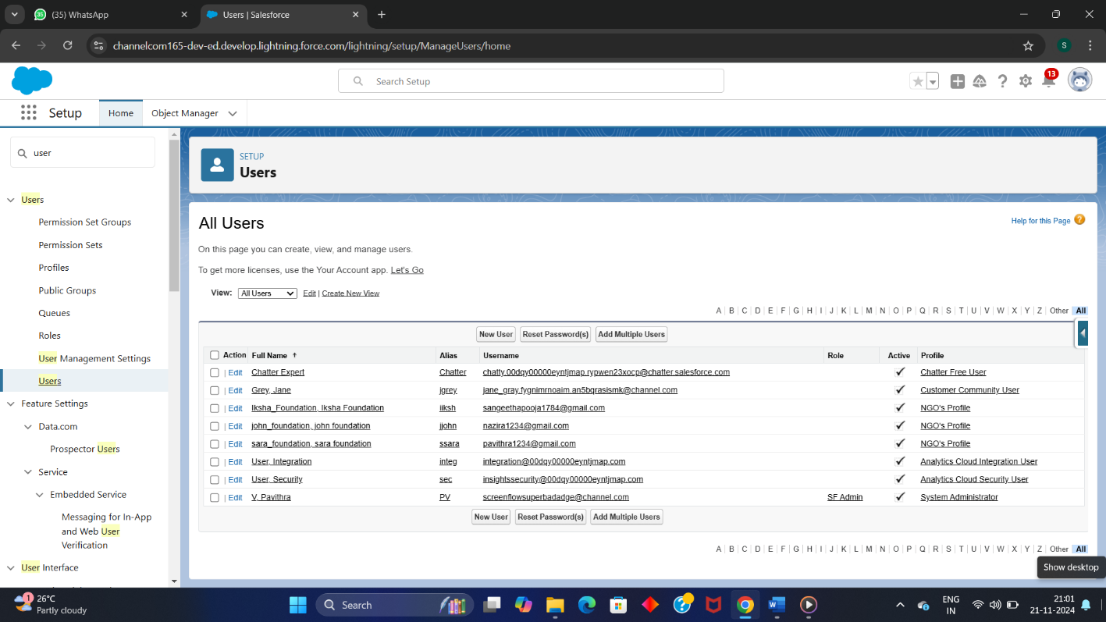

**Step 11: Create Public Groups.**

* Go to setup , search for Public groups .
* Create the public group for the users : Iksha , Nijami and Esha.
* By giving the group information such as label, group name .
* Click on save

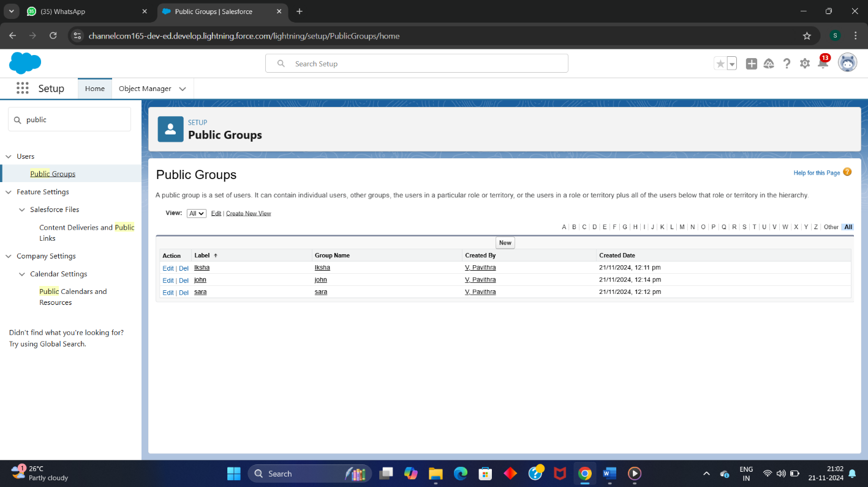

**Step 12: Creation of report types.**

* **Creation of Venue with Drop-off point with Volunteer.**
* Go to setup , search for report types in quick find bar.
* To create the venue with Drop-off with Volunteer report type click on new custom report .
* Then relate the object drop-off point and volunteer
* Click on save

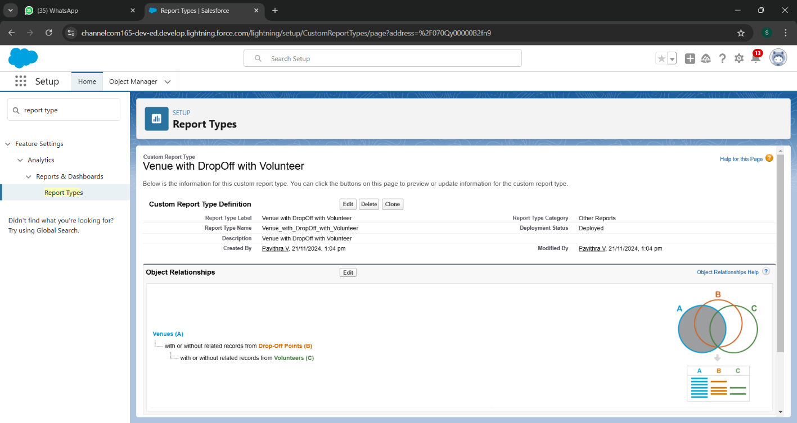

* **Creation of Volunteer with Execution Detail and Task.**
* Go to setup , search for report types in quick find bar.
* To create volunteer with Drop-off point and Task report type click on new custom report .
* Then relate the object task and execution details.
* Click on save

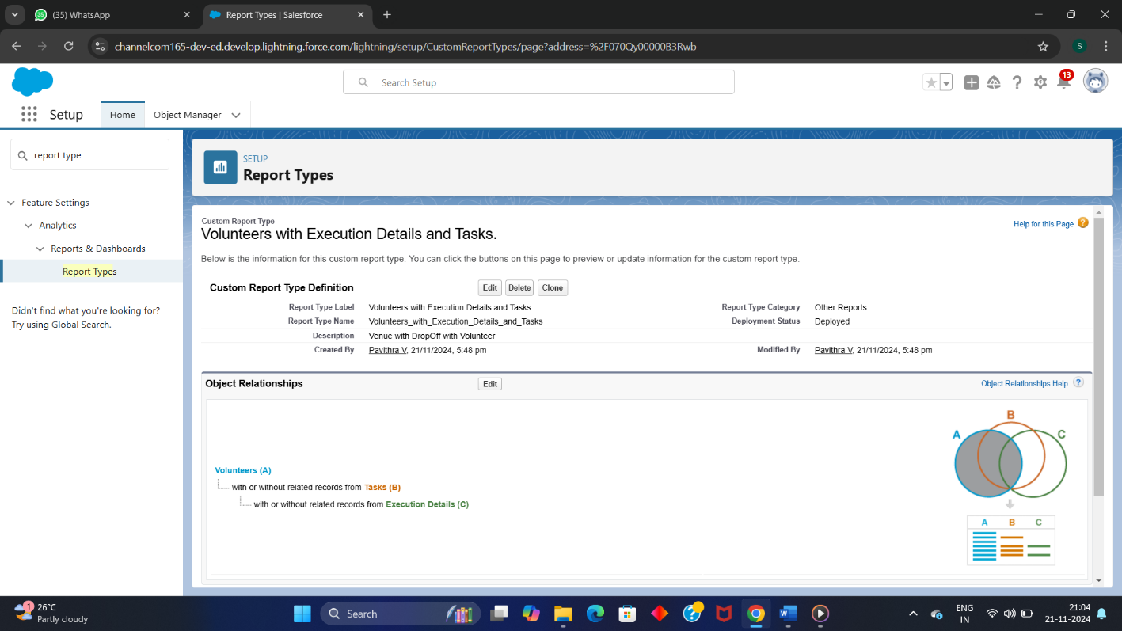

**Step 13: Creation of Reports.**

* **Creation of Venue with Drop-off point with Volunteer.**
* Go to food - connect in the app launcher
* To create new custom report , click on new report
* Select Venue with Drop -off with volunteer as report type .
* Start report by adding “Volunteer Name “in row and adding “venue name , Drop-off point name and Distance”
* Now click on save and run .

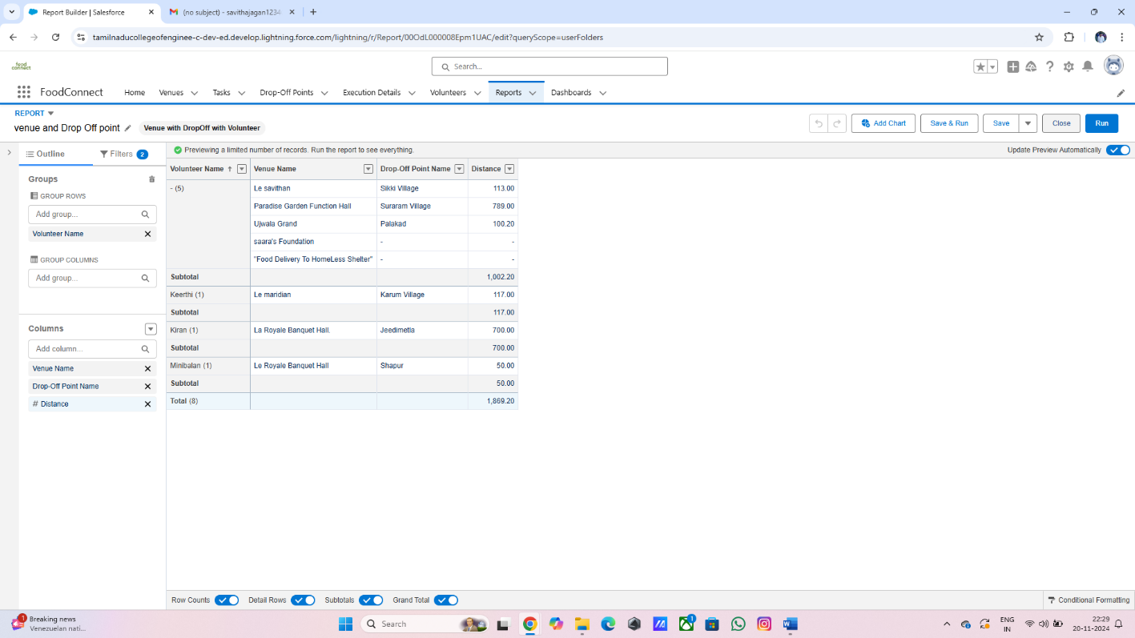

* **Creation of Volunteer with Execution Detail and Task**
* Go to food-connect in the app launcher
* To create new custom report click on new report
* Select Volunteer with Execution Detail and Task as report type .
* Start report by adding “Volunteer id “in row and adding “volunteer name , task name , Execution Detail name, rating ,date and owner name”
* Now click on save and run .

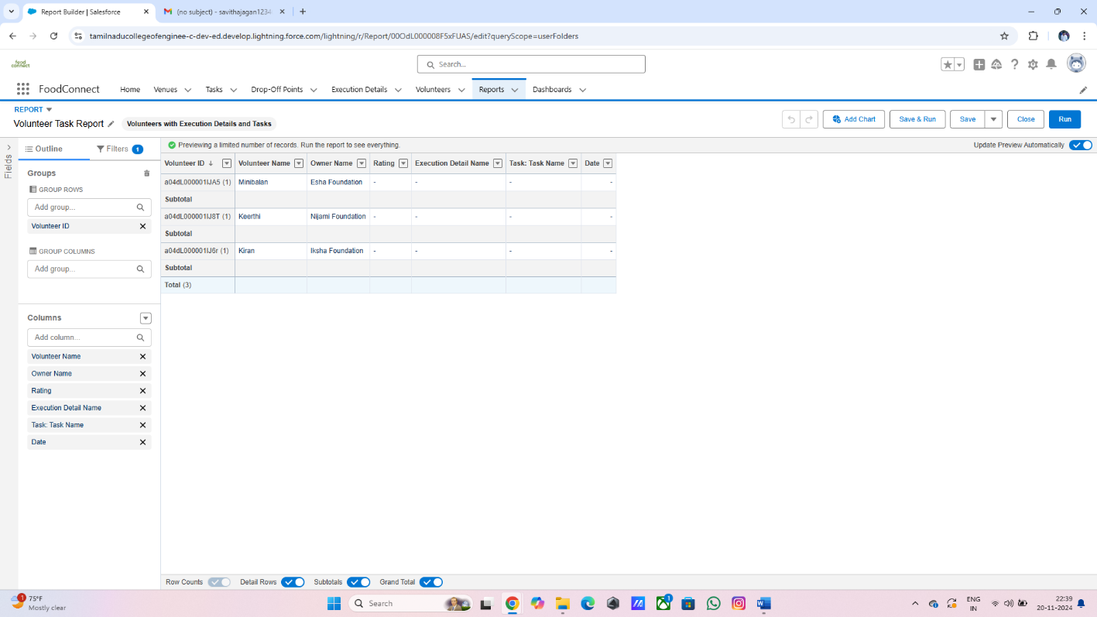

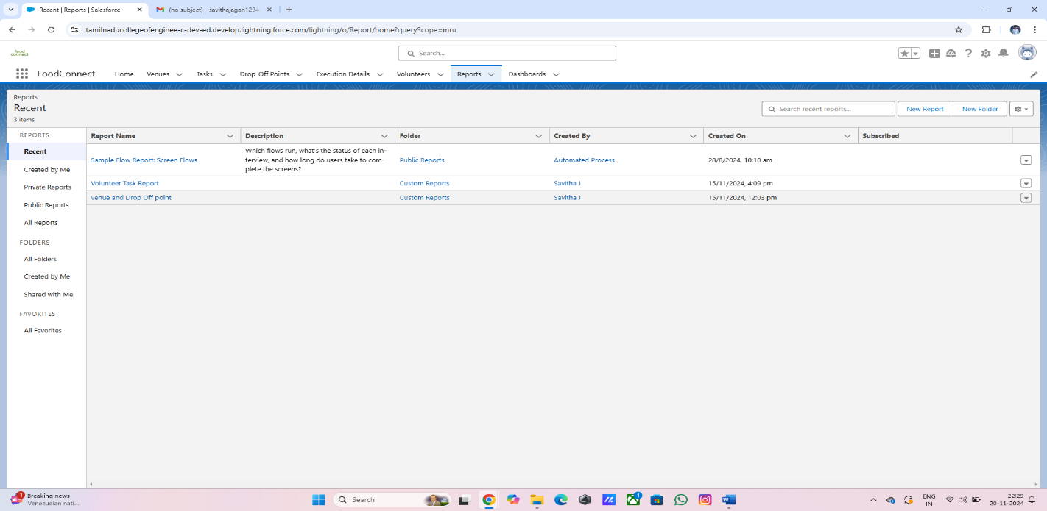

**Step 14: Creating Dashboard**

* **Adding venue with Drop-off reports .**

* Go to food connect app in app Launcher.
* In Dashboard tab , click on new Dashboard .
* Enter the name as Venue with Drop-off .
* Click on save.
* **Adding Volunteer with task reports.**

* Go to food connect app in app Launcher.
* In Dashboard tab , click on new Dashboard .
* Enter the name as Volunteer with task .
* Click on save.
* Created dashboard are named as Organization details .
* After assigning values to each tab , we renamed the dashboard Organization Details as Task Execution Details.
* Click on save.
* Finally add an picture to the dashboard by selecting the add image.
* Click on save.
* **Dashboard that are created by us shown in the below screenshot.**

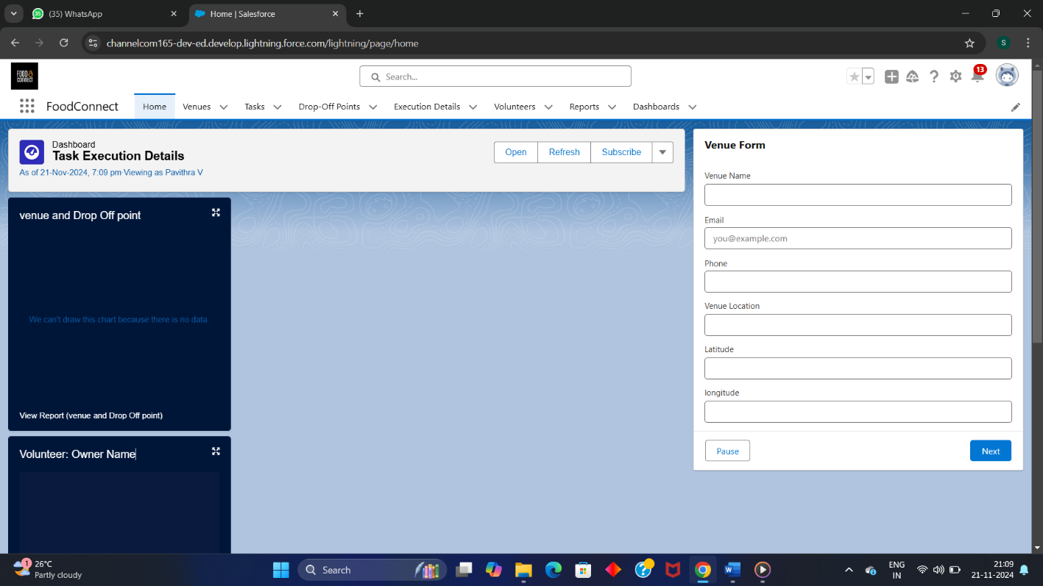

# Step 15: Creation of Sharing Rules.

* Go to the setup page, search for the sharing rule in the quick find bar.
* In Drop – off point sharing rule ,create new rule named as Rule 1 , Rule 2 , Rule 3.
* While creating the new rules give their necessary operators.
* Select the public user type based on your criteria.
* Click on save to display the created rules.

# 

**Step 16: Home page creation.**

* Go to setup page , search lightning app builder .
* Select new home page and name it as HOME page
* Search flow in component , then drag and drop it in the right corner section

Click on save and activate.

* Add foodconnect as assignment.
* Then add task Execution details in first section.
* Click on save .

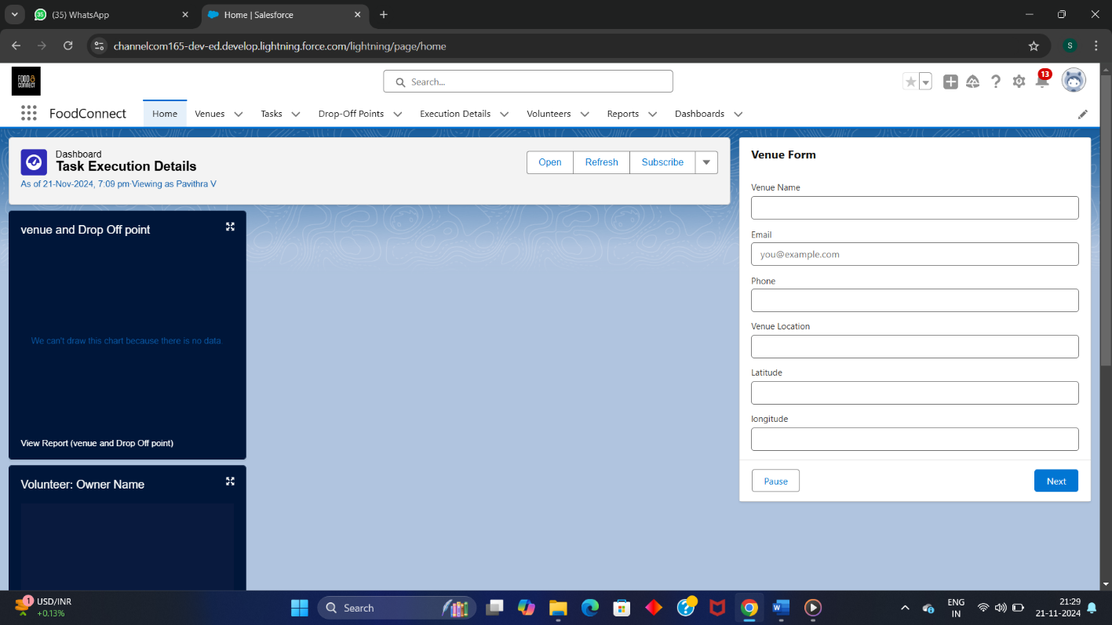

# Testing and Validation.

**Unit Testing (Apex Triggers):**

**Purpose:**

Unit testing is critical for validating that the business logic defined in apex triggers works correctly ,ensuring data manipulation (Insert, update ,Delete) behaves as expected.

**Approach For Testing Apex Triggers:**

* **Triggers Scenarios:**

**Food Donation Insert Trigger:**

When a food donation record is created ,ensure that the trigger process the information correctly and stores it in the appropriate salesforce objects.

**Donation Update Trigger:**

When status of a donation changes (eg: from “Pending” to “Accepted”),ensure that trigger reflects change across the system.

**Food Expiry Validation Trigger:**

Trigger validation to prevent donations of expired food.

**Recipient Notification Trigger:**

Send Email / SMS to the recipient (NGO) When a donation is successfully Recorded Or Updated.

## 6. Key Scenarios Addressed by Salesforce in the Implementation Project

This gives clarity that you are addressing various use cases or situations that Salesforce can handle during the implementation.



# 7. Conclusion

The Leftover Food Supply to the Poor project aims to address food wastage while simultaneously helping those in need by facilitating the donation of surplus or leftover food to the underprivileged. This initiative not only reduces food waste but also plays a critical role in providing nutritious meals to vulnerable populations, contributing to social welfare and community support.

The project relies on a well-designed Salesforce-based system that includes features for donors, volunteers, and NGOs to interact seamlessly. Key features of the system include:

* Donor Interface: A simple and intuitive platform for individuals or organizations to donate surplus food. The system ensures that donations are recorded with necessary details, such as food type, quantity, and expiration date.
* NGO/Volunteer Dashboard: A dashboard for recipient organizations (NGOs) and volunteers to manage donations, confirm pickups, and ensure that the donated food reaches those in need in a timely manner.
* Automated Notifications: An automated system for notifying donors and recipient organizations about donation submissions, confirmations, and status updates, ensuring smooth communication between all parties involved.
* Food Expiry Validation: A crucial validation step that ensures that donated food meets health standards by preventing the donation of expired items.

**Impact and Benefits:**

* **Social Impact**: The project helps reduce food wastage by redistributing surplus food to those who need it the most, alleviating hunger and improving the quality of life for marginalized communities.
* **Operational Efficiency**: The Salesforce-based system automates donation tracking, status updates, and notifications, ensuring efficient operations and real-time communication between donors, volunteers, and NGOs.
* **Sustainability**: By connecting food donors with organizations in need, the system promotes sustainability and environmental responsibility by diverting surplus food from landfills

**Future Considerations:**

* **Scalability**: As the system proves successful, it can be expanded to serve more regions, cities, or even countries, helping to scale the impact of the initiative.
* **Continuous Improvement**: The system should be periodically updated based on feedback from users (donors, volunteers, NGOs) to enhance usability, add new features, and improve system performance.

In conclusion, the **Leftover Food Supply to the Poor** project is a powerful solution to two major issues: food waste and hunger. By leveraging technology, community collaboration, and a thoughtful system design, the project contributes positively to society, supporting those in need while making a sustainable impact on reducing food waste.